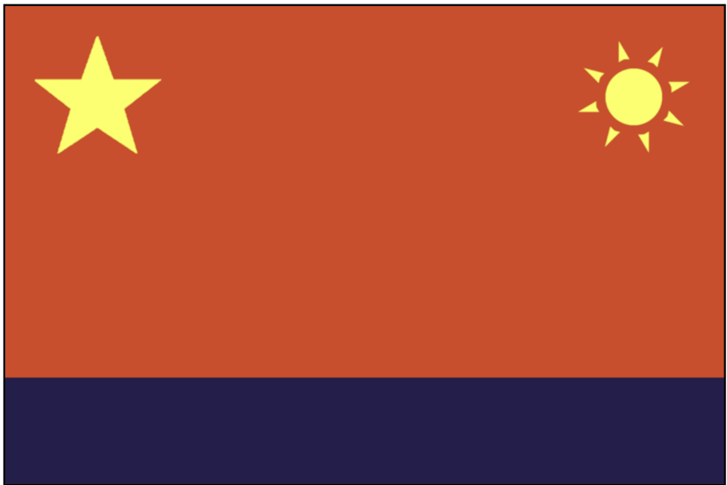


Population: 1646 CPA citizens, several hundred SAN refugees

Starting Crew, Resources and Units:
7 Untrained Crew
3 Security Units
1 Engineer Crew
1 Pilot Crew
2 Fighter Squadron Units
2 Ore
1 Fuel
5 Materials

The CPA may not be the superpower it was centuries ago, but your national identity as a major power is still strong. Before 'The Attack', the CPA was a stable and productive nation, and respected by many for what it was capable of. Prior to the attack, your population was nearly double that of the FAS, but your nation bore the brunt of the Wolves’ firestorm and your numbers are not what they were. Your citizens are grieving and you’ve become more isolationist as a result. However, don’t allow the other nations to forget your sacrifice when it comes to negotiating.

You have control over much of the Fleet's production of valuable Materials and Strytium Ore and your workers are loyal and motivated to keep the fleet running.

The FAS is an old enemy but you have more in common with them now than you do with the New Nations. You are concerned that the President of the Council was born a resident of the FAS – though legally the President is bound to neutrality, you should be observant and ensure it doesn't sway their decision-making.

The SAN are old friends, although in more recent times they've gradually been focusing more on themselves and your diplomatic ties have weakened.
Rosal are loud and boorish, but ultimately harmless, and can be useful allies if the FAS are getting their way too often.

Proxima are a challenge to negotiate and find consensus with but they bring important military and production support so must be tolerated as much as possible.

Gliese have an annoying habit of exhibiting a “New Nation” style rebellious spirit, but you try to stay on good terms with them given their control of important resources.

Helvetii is an enigma and a recent addition to the Council. They seem to have the “New Nation spark” but are very open minded and consistent with their neutral political approach. They could prove to be a good negotiator and ally.

The actions of the Wolves may have taken you by surprise but you always knew they would do something despicable. Even before 'The Attack' you knew they couldn't be trusted and their politicians were unredeemable. Every opportunity should be taken to show them that they haven't won and that they are not safe.

Reminder - The First Officer must report to the Fleet Map during Wolf attacks to direct the Icebreaker’s fighters.

Objectives

• Ensure the CPA is in a predominant position of power and influence going forward. Your production of the bulk of the fleet’s materials and ore will ensure that people listen to you.

• Try to maintain a neutral stance with regards to the other nations, unless one appears to be sympathetic towards the Wolves. Help maintain a neutral balance of political power amongst the nations.

• Take every opportunity to destroy Wolf forces and assets. They cannot be allowed to get
away with what they have perpetrated. Advocate for surveillance and proactive measures against Wolf influence and actions, even if individual rights are threatened.

